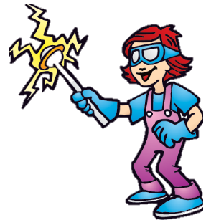

* **Harnessing Heat**
* **Magnetic Magic**
* **Sonic Sounds**
* **Lab Works**
* **Slime Time**
* **Glow Show**

**Includes these lessons and more:**

**This semester at Crazy Chemworks and Ready, Set, Science  
Chemworks** lets kids shake up a flask of fun in the lab as a junior chemist! They get familiar with real laboratory equipment, build and break molecules, and pick up some tricks on chemical changes.

**Ready, Set, Science** gets kids familiar with basic scientific principles and helps them build observational skills by looking at the world around them.

To enroll, visit our website at **NEPhoenix.MadScience.Org**Or call us at 480-222-2233

#### Age Range: 3 – 5th Day and Time: 2:05 – 3:10 PM Cost: $295 per child Dates: Jan 17 – May 8 (16 class dates) Skip Dates (no class): March 13

Mad Science after-school programs are not only educational, they’re also loads of fun! Children engage in hands-on activities, watch spectacular demonstrations, and explore scientific concepts for themselves.  
  
Each class comes with a Mad Science exclusive take-home project to keep the learning going at home.

**Mad Science at Archway Lincoln**